System and Software Architecture Description (SSAD)



PROJECT TITLE
LEMA FAMILY ACCOUNTABILITY SYSTEM
TEAM NO
#04

TEAM MEMBERS & ROLES
NAME | ROLES
Teawon Han | Project Manager
Zhen Huang | Feasibility Analyst
Ziming Wei | Operational Concept Engineer
Xiali Ma | Life Cycle Planner
Ying Yang | Life Cycle Planner
Ian Williams | Requirements Engineer
Kimberly Krause | IIV&V /  System Requirements Engineer

Version History
Date | Author | Version | Changes made | Rationale
10/06/11 | Zhen Huang | 2.1 | - Filled the session 1 and session 2.1.1-2.1.3 | - Initial draft for use with Instructional ICM-Sw v1.0
10/13/11 | Ziming Wei & Zhen Huang | 2.2 | - Updated 2.1.1-2.1.3  - Completed Section 2 | - Modify the all the diagrams. Update the content of the session from 2.1.1-2.1.3 .
10/23/11 | Teawon Han | 2.3 | - Updated 2.1 -2.2  - Modify architecture of system and user-case  - Updated and Insert more capabilities and course of action more specifically | - Based on ARB feedback.  - Based on discussion with team12  - Based on clients’ feedback
10/30/11 | Teawon Han | 2.4 | - Fix bug #5321 (specify about student’s information in Table 26)  - Update use case based on changed requirements  - Update and Insert more capabilities and course of actions. | - Bugzilla’s comments.  - Import file to input the grade information into database.
11/21/11 | Teawon Han | 3.1 | - Use case updated and artifact and information diagram is updated.  - Capabilities were updated | - According to the TA’s comments, use case was too detailed and there were missed artifacts.  - System management is not our project’s scope.
11/21/11 | Teawon Han | 3.1 | - For all use cases, I designed all class diagrams and sequence diagrams.  - Technology independent system design sections were deleted. | - Technology independent system section is not applicable in our system.
12/5/11 | Teawon Han | 3.2 | - Delete un-necessary process in action of cases. | - Login process is removed with description (as precondition)

Table of Contents
System and Software Architecture Description (SSAD) i
Version History ii
Table of Contents iii
Table of Tables iv
Table of Figures vi
1. Introduction 1
1.1 Purpose of the SSAD 1
1.2 Status of the SSAD 1
2. System Analysis 2
2.1 System Analysis Overview 2
2.2 System Analysis Rationale 25
3. Technology-Specific System Design 27
3.1 Design Overview 27
3.2 Design Rationale 48
4. Architectural Styles, Patterns and Frameworks 49

Table of Tables
Table 1: Actors Summary 2
Table 2: Artifacts and Information Summary 4
Table 3: Process Description 6
Table 4: Typical Course of Action (actor: student) 7
Table 5: Typical Course of Action (actor : parent) 7
Table 6: Alternate Course of Action (actor: student & parent) 8
Table 7: Uncertain course of Action ( actor : parent ) 8
Table 8: Uncertain course of Action ( actor : student ) 9
Table 9: Process description 9
Table 10: Typical Course of Action 10
Table 11 : Alternate Course of Action 11
Table 12 : Uncertain course of Action 11
Table 13: Process Description 12
Table 14: Typical Course of Action 12
Table 15: Alternative Course of Action 13
Table 16 : Alternate Course of Action 13
Table 17: Uncertain course of Action 14
Table 18: Uncertain course of action 14
Table 19: Uncertain course of Action 15
Table 20 : Process Description 15
Table 21 : Typical Course of Action (manually) 16
Table 22 : Typical Course of Action (Automatically) 17
Table 23: Alternate Course of Action (manually) 17
Table 24: Alternative course of Action (manually) 17
Table 25: Uncertain course of Action 18
Table 26: Process Description 19
Table 27: Typical Course of Action (update) 19
Table 28: Typical course of action (Delete) 20
Table 29: Typical course of Action (Add) 20
Table 30: Alternative Course of Action 20
Table 31: Process description 21
Table 32: Typical course of action 21
Table 33: Alternative course of action 21
Table 34: Alternative course of action 22
Table 35: Process description 22
Table 36 : Typical course of Action (Add) 22
Table 37: Typical course of Action 23
Table 38 : Alternative course of Action 23
Table 39: Process Description 24
Table 40: Typical course of Action 24
Table 41: Alternative course of Action 24
Table 42: Uncertain course of Action 25
Table 43: Hardware Component Description 29
Table 44: Software Component Description 30
Table 45: Review Error Description 31
Table 46: Send Message Class Description 32
Table 47: Request Report Class description 34
Table 48: Performance Input class description 36
Table 49: Resource Management Class Description 37
Table 50: User Management Class Description 39
Table 51: User Login Class Description 41
Table 52: Architectural Styles, Patterns, and Frameworks 49

Table of Figures
Figure 1: System Context Diagram 2
Figure 2: Artifacts and Information Diagram 4
Figure 3: Process Diagram 6
Figure 4: Hardware Component Class Diagram 27
Figure 5: Software Component Class Diagram 28
Figure 6: Deployment Diagram 29
Figure 7: Review Error 31
Figure 8: Send Message Class 32
Figure 9: Request Report Class 34
Figure 10: Performance Input class 36
Figure 11: Resource Management Class 37
Figure 12: User Management Class 39
Figure 13: User Login Class Diagram 41
Figure 14: Request Report Sequence Diagram 43
Figure 15: Grade Input Sequence Diagram 43
Figure 16:Input Attendance Info Sequence Diagram 44
Figure 17: Add New Resource Sequence Diagram 44
Figure 18: Input New User Info Sequence Diagram 45
Figure 19: Update User Info Sequence Diagram 45
Figure 20: Review Error Message Sequence Diagram 46
Figure 21: Request Report (parent) 46
Figure 22: User Login Sequence Diagram 47
Figure 23: Message Send Sequence Diagram 47
Figure 24: Rest Service Sequence Diagram 48

Introduction

Purpose of the SSAD
The purpose of this SSAD is to document the results of LEMA Pilot School Integrated Family Accountability System Project being developed. This SSAD will be used by the builder (programmer) as reference to the system architecture. The system being developed will be faithful to the architecture specified in this document. Furthermore, this document will be used by the maintainer and clients to help understand the structure of the system once the proposed system is delivered.

Status of the SSAD
This is version 3.1 SSAD for this project. This document is representing all specific logical architectures what system will have based on requirements. Context Diagram, Use Case Diagrams & Class Diagrams are included in this document with specific descriptions.

System Analysis

System Analysis Overview
LEMA Family Accountability system is aiming at offering an electronic alternative for teachers, students and parents from LEMA school access to the students learning information. The system will let users log in and review students' performance and information online and generate specific reports for users. Also, the LEMA system will help teachers to manage students' information better by the offering daily report to parents and better communication between
teachers, parents, and support staff.

System Context
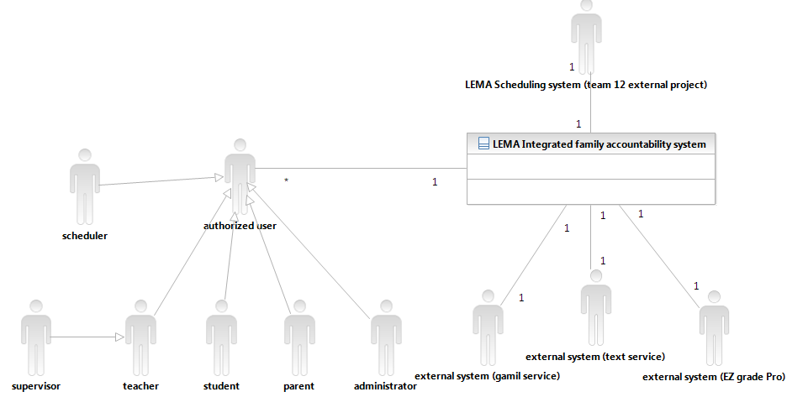
Figure 1: System Context Diagram
Table 1: Actors Summary
Actor | Description | Responsibilities
Administrator | A staff of LEMA School who is responsible for managing this system and database. | - Set access control for users  - Solve system errors (quarry errors)  - Maintain the system and updating database
Student | Student in LEMA School | - View performance reports  - Grade & Attendance reports  - View statuses of resources  - What resources are available?  - Who does have what?
Parent | Parents of LEMA School | - View student performance reports  - Grade & Attendance reports  - Receive notification from teachers  - Receive notification from system
Teacher | Teachers of LEMA School  (Access related students’  information) | - Input students’ data such as attendance, grade, etc.  - Notify parents  - View students’ performance reports  - Access only student data who is taking the teacher’s class
Supervisor | Teachers of LEMA School | - Same as Teachers  - Access all students’ information
Scheduler | Scheduler of LEMA School | - Team12’s LEMA scheduling system will login through our system
Gmail Service  (External service) | External email service for notification to parent | - Grade / Attendance report will be attached in email  - Attendance report will be sent automatically when student is absent.  - Grade report will be sent by teachers (Not decided)
Text message service  (External service) | External text message service for notification to parent | - Attendance information will be sent by system automatically or by teachers manually when student is absent
LEMA Scheduling System  (External project) | Team12’s project  Lists of classes and teachers are decided in here | - Provides the lists of classes and teachers for every semester.  - Provides information about ‘which student have what class in the semester’
EZ Grade Pro  (Exported file) | EZ Grade Pro is external application for maintaining grade information.  This program exports grade information as a text file. | - Provides grade information by exporting text type file.

Artifacts & Information
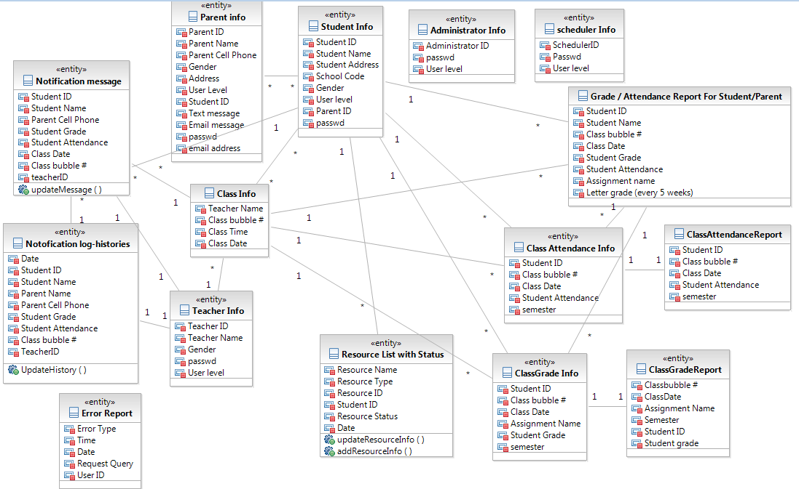
Figure 2: Artifacts and Information Diagram

Table 2: Artifacts and Information Summary
Artifact | Purpose
ATF-1: Student Information | Contains all the original data of all students in all the time.
ATF-2: Class Information | Contains all class information (this will be maintained by LEMA scheduling system-tema#12)
ATF-3: Attendance report of class for Teacher | Contains attendance information of chosen class at chosen semester. (charts are included)
ATF-4: Grade report of class for teacher | Contains grade information of chosen class at chosen semester. (charts are included)
ATF-5: Grade & Attendance report of student for students and parents | Contains grade & attendance information including charts and statistics data of a student
ATF-6: Resource List with status | Contains statuses and lists of books and other resources that student can borrow from the school
ATF-7: Notification Message | Contains attendance, grade or other information that teachers or system send to a parent by email or text message (Not decided)
ATF-8: Notification log-histories | Contains all the notification histories that are sent to parents by both teacher and system.
ATF-9: Internal system error report | Administrator can manage the system by logging this page. The artifact includes users’ authorities and exception report management.
ATF-10: Error Message | When system is running, if the errors are occurred, the error messages are saved.
ATF-11: Teacher Info | Teacher is different from supervisor.
ATF-12: Parent Info | Parent’s information includes personal info with student’s ID
ATF-13: Administrator Info | Administrator’s personal info
ATF-14: Scheduler Info | This is the account for LEMA scheduling system
ATF-15: Class Grade Info | All grade information for each class is saved
ATF-16: Class Attendance  Info | All attendance information for each class is saved

Behavior
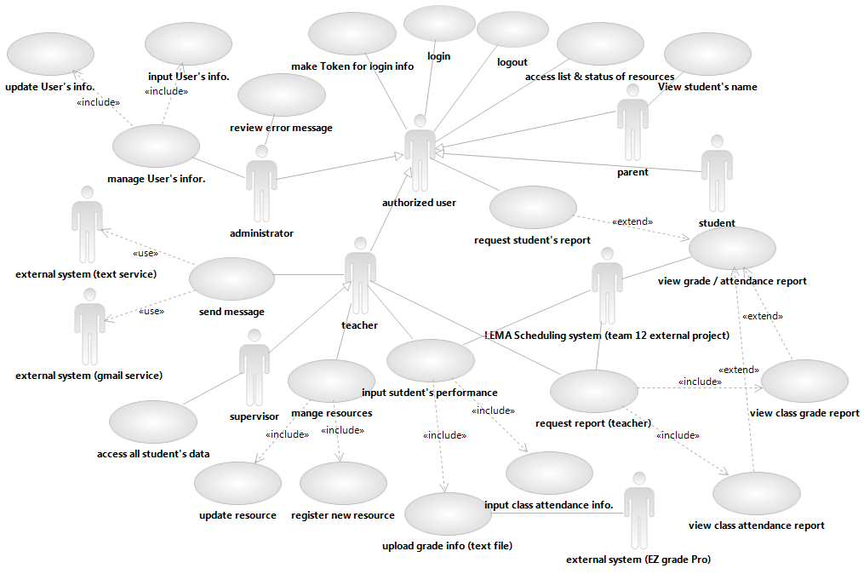
Figure 3: Process Diagram

Capabilities

Process of ‘Request student report’ for students and parents
Table 3: Process Description
Identifier | UC-1: Student and parents can check the performances (grade and attendance) in school
Purpose | Allow students and parents to review the performance information like grade and absences concurrently. So that students can make plan themselves.  Parents can help for students to make plan.
Requirements | Overall :  Students should be able to see where they are standing on their semester by attendance and grade reports with scatter plots and statistical data.  Parents can know what their children have problem.  CR-1 : Provide online interface  CR-2 : Scatter plot Reporting  CR-4 : Statistical Data
Development Risks | To make the report, we need lists of classes.  However, this data will be maintained by team12’s database.  If there is loss of data in requesting & receiving, report could not be published well
Pre-conditions | - Users are permitted to access the information by login.  - Users are students and parents  - Database has been recorded before users request report.
Post-conditions | - Student’s performance is displayed to users.

Table 4: Typical Course of Action (actor: student)
Seq# | Actor’s Action | System’s Response
1 | Click the "view performance" button.
2 |  | Show the lists of semesters.
3 | Choose Report Semester
4 | Click next
5 |  | Request class information to LEMA scheduling system
6 |  | Receive class information from LEMA scheduling system
7 |  | Return students performance page.  Generate the report of performance.
Table 5: Typical Course of Action (actor : parent)
Seq# | Actor’s Action | System’s Response
1 | Click the "view performance" button.
2 |  | Show the lists of ‘semester’ and ‘student’
3 | Choose semester and student
4 | Click next
5 |  | Request class information to LEMA scheduling system
6 |  | Receive class information from LEMA scheduling system
7 |  | Return students performance page.  Generate the report of performance.

Table 6: Alternate Course of Action (actor: student & parent)
Seq# | Actor’s Action | System’s Response
1 | Fill in the required fields (ID and Password) of identification to log in.
2 |  | Return the error messages that are representing failing to find the Password or ID.
3 | Click the "Forget the password" button.
4 |  | Return the questions that users set in order to find the ID and password.
5 | Fill the answer for the questions
6 |  | Check the answer. If answer is correct, return the password and ID.

Table 7: Uncertain course of Action ( actor : parent )
Seq# | Actor’s Action | System’s Response
1 | Click the "view performance" button.
2 |  | Show the lists of ‘semester’ and ‘student’
3 | Choose semester and student
4 | Click next
5 |  | Request class information to LEMA scheduling system
6 |  | Cannot receive class information from LEMA scheduling system
7 |  | Save error report
8 |  | Return error page.
9 | Click the “view performance”
Table 8: Uncertain course of Action ( actor : student )
Seq# | Actor’s Action | System’s Response
1 | Click the "view performance" button.
2 |  | Show the lists of semesters.
3 | Choose Report Semester
4 | Click next
5 |  | Request class information to LEMA scheduling system
6 |  | Cannot receive class information from LEMA scheduling system.
7 |  | Save Error report
8 |  | Return error page.

Process of ‘Request Report (teacher)’
Table 9: Process description
Identifier | UC-2: Teachers can check students performances (grade and attendance) in school
Purpose | Allow teachers to check the students’ performance like grade and absences concurrently. This helps teachers to manage students efficiently.
Requirements | Overall :  Teachers can know which student is good at studying based on grade report efficiently. In addition, teacher can advise or manage students at appropriate moment. (not too late)  CR-1 : Provide online interface  CR-2 : Scatter plot Reporting  CR-4 : Statistical Data
Development Risks | To make the report, we need lists of classes and teachers in this semester. If data quarry is broken in communicating between team12’s database and our system, report cannot be built accurately.  If there is loss of data in requesting & receiving, report could not be published well
Pre-conditions | - Users are permitted to access the information by login.  - Users are teachers and supervisors.  (one can access all students’ data whereas another cannot)  - Database has been recorded before users request report.  - Semester, report type, and class are selected by user.
Post-conditions | - Student’s performance is displayed to users.

Table 10: Typical Course of Action
Seq# | Actor’s Action | System’s Response
1 | Click the "view performance" button.
2 |  | - When the user is a teacher  Show the lists of semesters & classes that the teacher is teaching  - When the user is a supervisor  Show the lists of semesters & all classes
3 | Choose one of semesters
4 |  | Request class information of chosen semester to LEMA scheduling system
5 |  | Receive class information from LEMA scheduling system
6 |  | Show list of classes
7 | Choose one of classes & report type
8 |  | Return the grade (when report type is grade) or attendance (when report type is attendance) report for chosen class.  (row in table : students’ name)  (column of table : dates or dates with assignments)
9 | Click the “student’s name” on lists
10 |  | Return the summary report of student’s performance  (Shows the total number of absent and the average grades info in every class)  (There is no specific date when student absented or specific grades what score student got from what assignment or test)
Table 11 : Alternate Course of Action
Seq# | Actor’s Action | System’s Response
1 | Fill in the required fields (ID and Password) of identification to log in.
2 |  | Return the error messages that are representing failing to find the Password or ID.
3 | Click the "Forget the password" button.
4 |  | Return the questions that users set in order to find the ID and password.
5 | Fill the answer for the questions
6 |  | Check the answer. If answer is correct, return the password and ID.
7 | Click " home" button to go to home page.

Table 12 : Uncertain course of Action
Seq# | Actor’s Action | System’s Response
1 | Click the "view performance" button.
2 |  | - When the user is a teacher  Show the lists of semesters & classes that the teacher is teaching  - When the user is a supervisor  Show the lists of semesters & all classes
3 | Choose one of semesters
4 |  | Request class information of chosen semester to LEMA scheduling system
5 |  | Cannot receive class information from LEMA scheduling system
6 |  | Save Error report
7 |  | Show Error page
8 | Click “view performance” button

Process of ‘Input students’ performance’
Table 13: Process Description
Identifier | UC-3: Teachers input students’ data into system everyday  (grade & attendance)
Purpose | Allow teachers to maintain students’ performance information like grade and absences.
Requirements | CR-1: Client requires that aggregate student data calculations  such as average and standard deviation be presented for  grades.  CR-6 : Maintaining students’ data everyday not every 5 weeks
Development Risks | If teachers forget inputting data, reports are not accurate.  Database can be get damage because of hardware or software problem (incorrect management)  Quarry message can be fail to input the data.
Pre-conditions | - Users are permitted to access the information.  - Users are teachers and supervisors.  - List of students and classes have been saved before the inputting  the data
Post-conditions | - The grade and attendance information are updated and saved in the database.

Table 14: Typical Course of Action
Seq# | Actor’s Action | System’s Response
1 | Click the “input student performance”
2 |  | Show options (report type & semester)
3 | Select the “attendance"
4 | Select the semester
5 |  | Request class information at the date to LEMA scheduling system
6 |  | Receive class information from LEMA scheduling system
7 |  | Show list of classes
8 | Select class
9 |  | Return the attendance input page
10 | Input attendance information
11 | Click “input/update” to submit
12 |  | Saved the changes to the database.
Table 15: Alternative Course of Action
Seq# | Actor’s Action | System’s Response
1 | Click the “input student performance”
2 |  | Show options (report type & semester)
3 | Select the “grades”
4 | Select the semester
3 |  | Request class information at the semester to LEMA scheduling system
4 |  | Receive class information from LEMA scheduling system
5 |  | Show list of classes
6 | Select class
7 | Select exported file and click the upload button
8 |  | Input grade information into database
9 |  | Return grade report for the class

Table 16 : Alternate Course of Action
Seq# | Actor’s Action | System’s Response
1 | Fill in the required fields (ID and Password) of identification to log in.
2 |  | Return the error messages that are representing failing to find the Password or ID.
3 | Click the "Forget the password" button.
4 |  | Return the questions that users set in order to find the ID and password.
5 | Fill the answer for the questions
6 |  | Check the answer. If answer is correct, return the password and ID.  If it is incorrect, go to Seq#4 with error message.

Table 17: Uncertain course of Action
Seq# | Actor’s Action | System’s Response
1 | Click the “input student performance”
2 |  | Show options (report type & semester)
3 | a) Select the " grade”  b) Select the “attendance"
4 | Select semester
5 |  | Request class information at the semester to LEMA scheduling system
6 |  | Cannot receive class information from LEMA scheduling system
7 |  | Save Error Report
8 |  | Show Error page
9 | Click “input student’s performance”
10 |  | Go to Seq#1

Table 18: Uncertain course of action
Seq# | Actor’s Action | System’s Response
1 | Click the “input student performance”
2 |  | Show options (report type & semester)
3 | Select the “attendance"
4 | Select date
5 |  | Request class information at the date to LEMA scheduling system
6 |  | Receive class information from LEMA scheduling system
7 |  | Show list of classes
8 | Select class
9 |  | Show attendance input page
10 | Input attendance information of class
11 | Click “update/submit” button
12 |  | Cannot save the data into database
13 |  | Save Error Report
14 |  | Show Error page
15 | Click “input student’s performance”
16 |  | Go to Seq#1
Table 19: Uncertain course of Action
Seq# | Actor’s Action | System’s Response
1 | Click the “input student performance”
2 |  | Show options (report type & semester)
3 | Select the “grade"
4 | Select date
5 |  | Request class information at the date to LEMA scheduling system
6 |  | Receive class information from LEMA scheduling system
7 |  | Show list of classes
8 | Select class
9 | Select exported file and click the upload button
10 |  | Lose connection with database
11 |  | Cannot save the data into database
12 |  | Save Error Report
13 |  | Show Error page
14 | Click “input student’s performance”
15 |  | Go to Seq#1

Process ‘send message’ to let parents know student’s performance
Table 20 : Process Description
Identifier | UC-4 : Notify parents the students’ school performances
Purpose | Allow parents to review the performance information of students like grade and absences automatically.  Teachers can send notifications to the parents manually.
Requirements | CR -1 : Provide online interface  (Teachers, parents, and students must be able to access  the system through the Internet)  CR-9 : Track Parent Notifications  (Client requires that a communication & notice logs  between teachers and parents)
Development Risks | The message sender (external system) has internal problem suddenly.  The message sender (external system) stops the service or increase the fee for a message.  Message sending requests are fail from our system to external system.
Pre-conditions | - Users are permitted to access the information.  - Users are teachers.  - Not only list of students and classes, but also grade and  attendance information have been inputted before notice
Post-conditions | - Parents receive the notification.  - Updating log message histories.

Table 21 : Typical Course of Action (manually)
Seq# | Actor’s Action | System’s Response
1 | Click the "send message" button.
2 |  | - When the user is a teacher  Show the lists of related students  - When the user is a supervisor  Show the lists of all students
3 | Choose one of students
4 | Input messages
5 | Click send
6 |  | Send message
7 |  | Update log histories
8 |  | Show execution success page

Table 22 : Typical Course of Action (Automatically)
Seq# | Actor’s Action | System’s Response
1 |  | Check all classes’ grade and attendance information are inputted everyday
2 |  | Send the message within report.
3 |  | Update log histories
4 | Parents receive the email

Table 23: Alternate Course of Action (manually)
Seq# | Actor’s Action | System’s Response
1 | Fill in the required fields of identification to log in.
2 |  | Return the information of failing to find the password or ID.
3 | Select the "Forget the password" button.
4 |  | Return the questions that users set in order to find the ID and password.
5 | Fill the answer for the questions
6 |  | Check the answer. If answer is correct, return the password and ID.

Table 24: Alternative course of Action (manually)
Seq# | Actor’s Action | System’s Response
1 | Click the "view performance" button.
2 |  | - When the user is a teacher  Show the lists of semesters & classes that the teacher is teaching  - When the user is a supervisor  Show the lists of semesters & all classes
3 | Choose one of semesters and report type(grade or attendance)
4 |  | Request class information to LEMA scheduling system
5 |  | Receive class information from LEMA scheduling system
6 |  | Show list of classes
7 | Choose class
8 | Click next
9 |  | Return the grade or attendance report for chosen class.  (row in table : students’ name)  (column of table : dates with assignment or dates)
10 | Click the “student’s name” on lists
11 |  | Return the summary report of student’s performance  (Shows the total number of absent and the average grades info in every class)  (There is no specific date when student absented or specific grades what score student got from what assignment or test)
12 | Click ‘send message’ button to send the absent and grade information to parents
13 |  | Send message with performance report
14 |  | Update log histories
15 |  | Show execution success page

Table 25: Uncertain course of Action
Seq# | Actor’s Action | System’s Response
1 | Click the "view performance" button.
2 |  | - When the user is a teacher  Show the lists of semesters & classes that the teacher is teaching  - When the user is a supervisor  Show the lists of semesters & all classes
3 | Choose one of semesters and report type(grade or attendance)
4 |  | Request class information to LEMA scheduling system
5 |  | Cannot receive class information from LEMA scheduling system
6 |  | Save Error report
7 |  | Show Error page
8 | Click the “view performance” button
9 |  | Go to Seq#1

Process of ‘manage resources’
Table 26: Process Description
Identifier | UC-5: Manage resources
Purpose | Allow teachers can manage the resources.
Requirements | Resource status will be shown by web concurrently.
Development Risks | If the system should support web-based resources, not only lists and status of resources, space is problem to handle all contents.
Pre-conditions | - Users are permitted to access the information.  - Users are teachers and supervisors.  - Resource lists should be recorded in database.
Post-conditions | - Updated / added / deleted resources in database

Table 27: Typical Course of Action (update)
Seq# | Actor’s Action | System’s Response
1 | Click the "Manage resources" button.
2 |  | Show the lists of resources with statuses
3 | Choose one of resources
4 | Click update
5 |  | Show the resource’s specific information
6 | Input information
7 | Click Conform
8 |  | Update information of the resource
9 |  | Show the list of resources

Table 28: Typical course of action (Delete)
Seq# | Actor’s Action | System’s Response
1 | Click the "Manage resources" button.
2 |  | Show the lists of resources with statuses
3 | Choose one of resources
4 | Click delete
5 |  | Delete the resource information from database.
6 |  | Show the list of resources

Table 29: Typical course of Action (Add)
Seq# | Actor’s Action | System’s Response
1 | Click the "Manage resources" button.
2 |  | Show the lists of resources with statuses
3 | Click Add
4 |  | Show the form for resource information
5 | Put resource information & click submit
6 |  | Add the resource information into database.
7 |  | Show the list of resources
Table 30: Alternative Course of Action
Seq# | Actor’s Action | System’s Response
1 | Fill in the required fields of identification to log in.
2 |  | Return the information of failing to find the password or ID.
3 | Select the "Forget the password" button.
4 |  | Return the questions that users set in order to find the ID and password.
5 | Fill the answer for the questions
6 |  | Check the answer. If answer is correct, return the password and ID.  If the answer is incorrect, go to Seq#4
7 | Click " home" button to go to home page.
8 |  | Return main page that contains different functions.

Process ‘Access lists & status of resources’
Table 31: Process description
Identifier | UC-6: access resources
Purpose | Allow teachers and students to access status of resource to borrow.
Requirements | CR -3: Reservation system  Resource status will be shown by web concurrently.
Development Risks | If the system should support web-based resources, not only lists and status of resources, space is problem to handle all contents.
Pre-conditions | - Users are permitted to access the information.  - Users are teachers, parents and students.  - Resource lists should be recorded in database.
Post-conditions | - Confirm resources’ status, system show users the status of resource

Table 32: Typical course of action
Seq# | Actor’s Action | System’s Response
1 | Click the "Access resources" button.
2 |  | Show the lists of resources with statuses
3 | Choose one of resources
4 |  | Show deadline and status

Table 33: Alternative course of action
Seq# | Actor’s Action | System’s Response
1 | Click the "Access resources" button.
2 |  | Show the lists of resources with statuses
Table 34: Alternative course of action
Seq# | Actor’s Action | System’s Response
1 | Fill in the required fields of identification to log in.
2 |  | Return the information of failing to find the password or ID.
3 | Select the "Forget the password" button.
4 |  | Return the questions that users set in order to find the ID and password.
5 | Fill the answer for the questions
6 |  | Check the answer. If answer is correct, return the password and ID.  If it is incorrect, go to Seq#4 with error message.

Process ‘manage student information’
Table 35: Process description
Identifier | UC-7: Manage Students’ information
Purpose | Allow administrator to manage the student information.  This function is necessary to initialize and maintain the system
Requirements | CR-11: Different permission for data access
Development Risks | Management should be expert in managing database. If database is changed incorrectly, all data that is recorded will be lost.
Pre-conditions | - Users are permitted to access the information.  - User is the administrator.  - Structure of database should be decided and backup.
Post-conditions | - Students’ information is updated and saved in database (not defined specific information but, I assume that student’s name, ID, semester, graduate year, school number)

Table 36 : Typical course of Action (Add)
Seq# | Actor’s Action | System’s Response
1 | Select the “Student information management" button.
2 |  | Return students’ information management page with the list of student
3 | Click ‘add student’
4 |  | Show input form for student’s information
6 | Input student’s information
7 | Click "add" button
8 |  | Insert student’s information into database.
9 |  | Show inserted student’s data

Table 37: Typical course of Action
Seq# | Actor’s Action | System’s Response
1 | Select the "Student information management" button.
2 |  | Return students’ information management page with the list of student
3 | Click student
4 |  | Show the student’s information
6 | Click "update" button
7 |  | Show the update page (boxes filled with past information)
8 | Change student’s information.
9 |  | Update student’s information.
10 |  | Show updated student’s data

Table 38 : Alternative course of Action
Seq# | Actor’s Action | System’s Response
1 | Fill in the required fields (ID and Password) of identification to log in.
2 |  | Return the error messages that are representing failing to find the Password or ID.
3 | Click the "Forget the password" button.
4 |  | Return the questions that users set in order to find the ID and password.
5 | Fill the answer for the questions
6 |  | Check the answer. If answer is correct, return the password and ID.  If the answer is incorrect, go to Seq#4 with error message.

Process of ‘Login & Logout’ and ‘Make Token’
Table 39: Process Description
Identifier | UC-7: Authorization System
Purpose | All users should be authorized by system.
Requirements | CR-11: Different permission for data access  (Clients need certain administrator functions to manage  database and maintain the system)
Development Risks | Based on permission info in database, every user will be able to access appropriately
Pre-conditions | - User information is saved in database
Post-conditions | - Users will get token.

Table 40: Typical course of Action
Seq# | Actor’s Action | System’s Response
1 | Fill in the required fields (ID and Password) of identification to log in.
2 |  | Check the ID and Password
3 |  | Make a Token
4 |  | Return User’s main page.

Table 41: Alternative course of Action
Seq# | Actor’s Action | System’s Response
1 | Fill in the required fields (ID and Password) of identification to log in.
2 |  | Return the error messages that are representing failing to find the Password or ID.
3 | Click the "Forget the password" button.
4 |  | Return the questions that users set in order to find the ID and password.
5 | Fill the answer for the questions
6 |  | Check the answer. If answer is correct, return the password and ID.  If the answer is incorrect, go to seq#4 with error message.

Table 42: Uncertain course of Action
Seq# | Actor’s Action | System’s Response
1 | Fill in the required fields (ID and Password) of identification to log in.
2 |  | Check the ID and Password
3 |  | Fail to make a Token
4 |  | Return login page

Modes of Operation
The LEMA Integrated Family Accountability System, as we envision implementing it, will operate in only one mode, so nothing further need be said of modes of operation.

System Analysis Rationale
Based on how users interact with the system, we have identified 2 classes of operational stakeholders:
- Administrator – this is the user who has responsibility to access all of the system, and manage the levels of permission for normal users such as teachers, students and parents.
- Normal Users – These are users who have limited access to the system. They can be categorized as two kinds of teachers, students and parents. And as different roles, they have different level of access.
  - Teachers: Access limited students’ information. They can access grades and
attendance information of students who are taking the teachers’ class.
  - Supervisors: access all students’ data.
  - Students: access only own data
  - Parents: access only their children’s data
  - Administrator: access all system and data
  - Scheduler: access only class information in LEMA Scheduling system.

And there is one external system actor that exports data to LEMA Integrated Family

Accountability System:
LEMA Integrated Scheduling System – provides scheduling system for teachers to arrange course schedule and students to choose courses. LEMA Integrated Scheduling System has been building by CSCI 577 team12. The clients want to interact between two systems, Family accountable system and Scheduling System.

Technology-Specific System Design

Design Overview

System Structure
The following Hardware Component Diagram shows the Hardware structure. The web/application server will be connected with two types workstations through the Internet Network and provides Database system access. One workstation including EZ grade pro is for teachers whereas another one is for student and parent. In addition, two external services would be connected our system through the Internet Network as well.
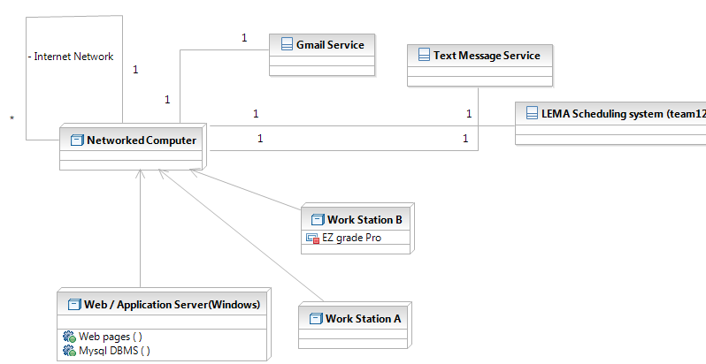
Figure 4: Hardware Component Class Diagram

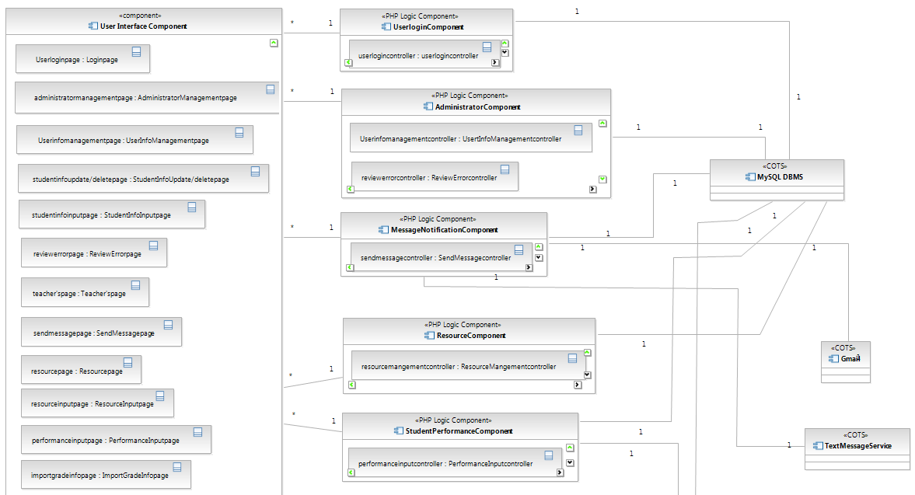
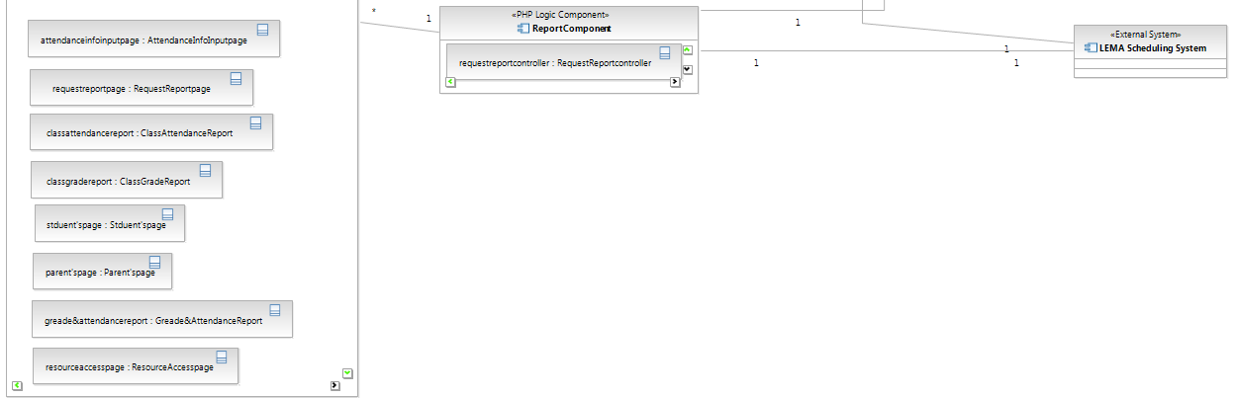
Figure 5: Software Component Class Diagram

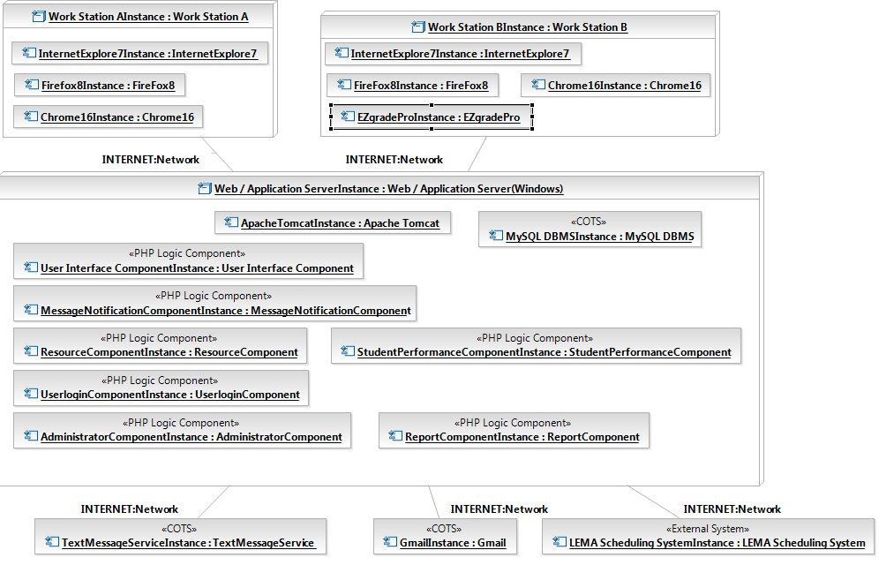
Figure 6: Deployment Diagram

Table 43: Hardware Component Description
Hardware Component | Description
Web/Application Server | A Web Application Server that accepts connections from general user and administrator Workstations. Such connections are forwarded to the Web Application Server through the Internet Area Network. The Web Application server communicates with the middleware and provides database access.
Work Station A | A workstation A is connected with Web/Application Server through the Internet network. All users can access the system by the workstation A.  This workstation is for parent, student, administrator, counselor, and scheduler.
Work Station B | A workstation B is connected with Web/Application Server through the Internet network. In addition, workstation B includes EZgradePro which is application for teacher to maintain students’ grade information.  This workstation is for teacher.
Gmail Service | This is external email service that is supported by Google.
Text Message Service | This is external text message service that is supported by Moeze
LEMA Scheduling System | This is 577’s another project. This system will get user information from our system.  Our system will get class information from LEMA scheduling system.

Table 44: Software Component Description
Software Component | Description
User Interface Component | This component contains LEMA School family accountable system web pages.
User Login Component | This component allows users to access appropriate information. Teacher can access their classes and students’ information. Supervisor can access all classes and students’ information.  Parent and student can access their classes’ information.  Administrator can manage users’ information and error messages.
Administrator Component | This component includes functions (user information management and error message management) to maintain user information and system.
Message Notification Component | This component includes function to send parent text messages and emails. This component works with external systems (Mozeo and Gmail)
Resource Management Component | This component helps teacher to maintain resource information.  Teachers can add/update/delete resources.
Student Performance Component | This component includes functions that relevant to management students’ grade & attendance information. Attendance information would be inputted by teacher on the web page, but grade information will be inputted by uploading the file exported from EZ grade Pro.
Report Component | This component shows users grade and attendance report.  For teachers, class grade/attendance report will be supported.  For parents and students, student’s grade/attendance report of every class will be supported.
DB Connector Component | Using Apache, each logic component connects with DBMS.
MYSQL DBMS | This is the Database Management System (DBMS) that stores all data used by the LEMA family accountable System.
External Network Service Connector | This is
LEMA Scheduling System | This system will get user information from our system.  Our system will get class information from the system.
Text Message Service | This is external system which is supporting text message service.
Gmail | This is external system which is supporting email service.

Design Classes

Review Error Class
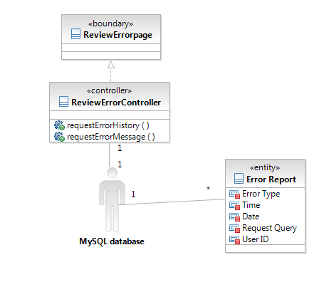
Figure 7: Review Error
Table 45: Review Error Description
Class | Type | Description
Review Error page | Boundary | Display the list of errors and specific information of the error.
Review Error Controller | Controller | Controller will get error information from database.
Error Report | Entity | This entity includes error type, time, date, request query and user ID whose executed the query.
MySQL database<<COTS>> | Component | MySQL Database will be used as a DataBase Management System

Send Message Class
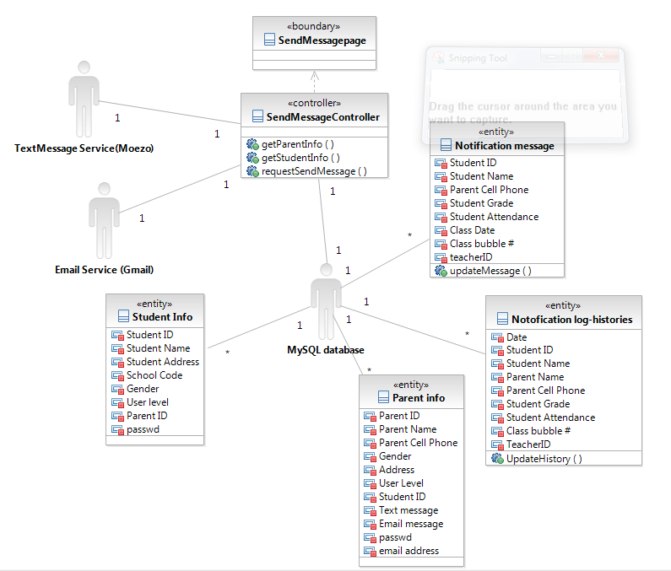
Figure 8: Send Message Class
Table 46: Send Message Class Description
Class | Type | Description
Send Message page | Boundary | Display the form to choose student and message type. In addition, there is textbox to input the message which teacher send to parent.
Send Message Controller | Controller | This controller interacts with database with Text Message Service and Email service. Based on parent’s preference, message type would be decided.
Notification Message | Entity | This entity includes all attendance information with student ID, class ID, and Semester.
Notification log history | Entity | This entity includes all grade information with student ID, class ID(class bubble #), and semester.
Student Info | Entity | This represents basic information(name, studentID, gender, address, user level, schoolcode) and parentID for relationships.
Parent Info | Entity | All parent information is including student’s ID to represent relationships. To message notice service, phone# and email address information are included. To represent parent’s preference for message notice type, text message and email message attributions will have Boolean value.
MySQL database<<COTS>> | Component | MySQL Database will be used as a Database Management System.
Email Service<<COTS>> | Component | Gmail service would be used to send email to parent by system and teacher. (grade & attendance)
Text Message Service<<COTS>> | Component | Text message service would be used to send text to parent by system and teacher. ( grade & attendance)

Request Report Class
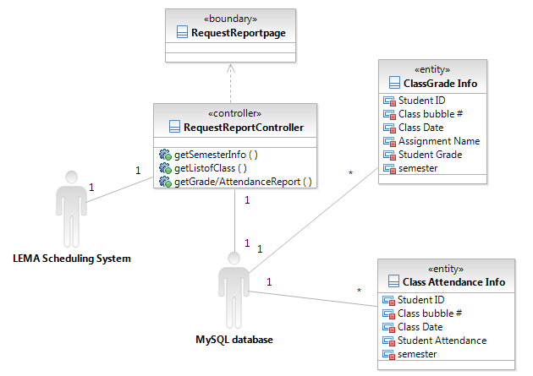
Figure 9: Request Report Class
Table 47: Request Report Class description
Class | Type | Description
Request Report page | Boundary | Display the information about attendance and grade of classes.  However, depending on user type, information would be different.  Teacher can see their classes.  Supervisor can see all classes.  Student and parent can see their classes.
Request Report Controller | Controller | This controller interacts with database with LEMA schedule system to get class information.
Class Grade Info | Entity | This entity includes all attendance information with student ID, class ID, and Semester.
Attendance info | Entity | This entity includes all grade information with student ID, class ID(class bubble #), and semester.
MySQL database<<COTS>> | Component | MySQL Database will be used as a Database Management System.
LEMA Scheduling System | Component | LEMA Scheduling System handles class information. Therefore, our system would request the scheduling system to get class information.  LEMA family accountability system will handle user information and grade/attendance information. Therefore, the scheduling system will request the family accountability system to get user information.

Performance Input Class
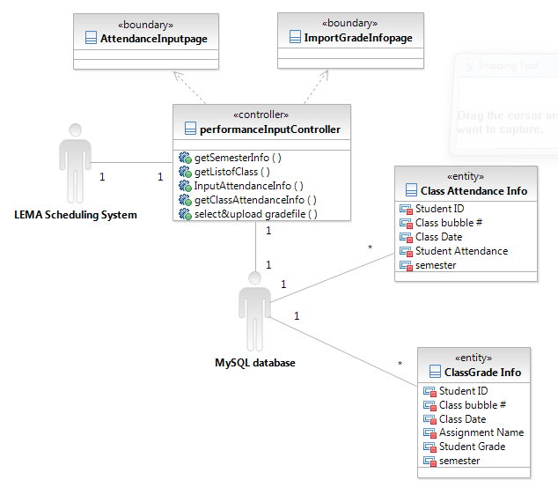
Figure 10: Performance Input class
Table 48: Performance Input class description
Class | Type | Description
Import Grade Info page | Boundary | Display the page for importing grade info file that is exported by EZ grade Pro.
Attendance Input page | Boundary | Display the form to input attendance information by teacher.
Performance Input Controller | Controller | This controller interacts with not only database, but also LEMA scheduling system to get class information.
Class Attendance Info | Entity | This entity includes all attendance information with student ID, class ID, and Semester.
Class Grade Info | Entity | This entity includes all grade information with student ID, class ID(class bubble #), and semester.
MySQL database<<COTS>> | Component | MySQL Database will be used as a Database Management System.
LEMA Scheduling System | Component | LEMA Scheduling System handles class information. Therefore, our system would request the scheduling system to get class information.  LEMA family accountability system will handle user information and grade/attendance information. Therefore, the scheduling system will request the family accountability system to get user information.

Resource Management Class
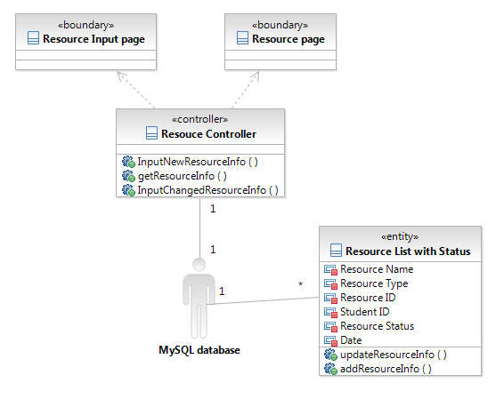
Figure 11: Resource Management Class
Table 49: Resource Management Class Description
Class | Type | Description
Resource page | Boundary | Display the resource information and forms to update the information.  This boundary includes delete function.
Resource Info Input page | Boundary | Display the users’ information and forms to input new resource information (status, title, type)
Resource Controller | Controller | This controller includes functions, input, update, and delete resource information.
Resource List with Status | Entity | To represent resource, this includes name, type, id, and status.  In addition, student id is included to know who borrow the item. To represent due-date, ‘date’ information is included.
MySQL database<<COTS>> | Component | MySQL Database will be used as a Database Management System.

User Management Class
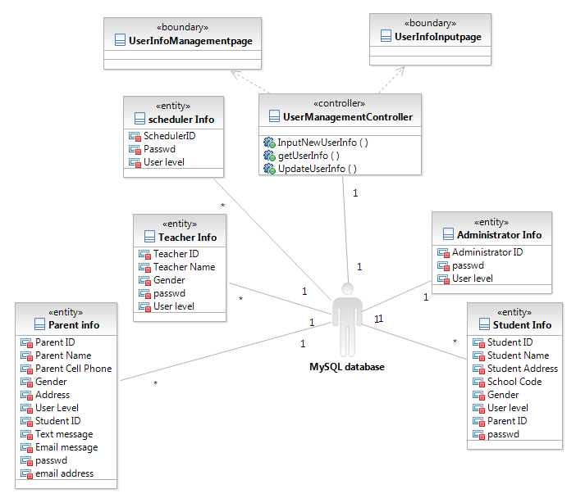
Figure 12: User Management Class
Table 50: User Management Class Description
Class | Type | Description
User Info Management page | Boundary | Display the users’ information and forms to update the information.  This boundary includes delete function.
User Info Input page | Boundary | Display the users’ information and forms to input new user’s information.
User Management Controller | Controller | This controller includes functions, input, update, and delete user information.
Administrator Info | Entity | There is an administrator who can manage user information. Only administrator would be able to input all user information.
Parent Info | Entity | All parent information is including student’s ID to represent relationships. To message notice service, phone# and email address information are included. To represent parent’s preference for message notice type, text message and email message attributions will have Boolean value.
Teacher Info | Entity | This represents basic information including name, id, password, and gender.  To distinguish between normal teacher and supervisor, there is level info.
Student Info | Entity | This represents basic information and parentID for relationships.
Scheduler Info | Entity | This represent basic information and User level to recognize different user type.  This user information would be maintained for LEMA scheduling system
MySQL database<<COTS>> | Component | MySQL Database will be used as a Database Management System.

User Login Class

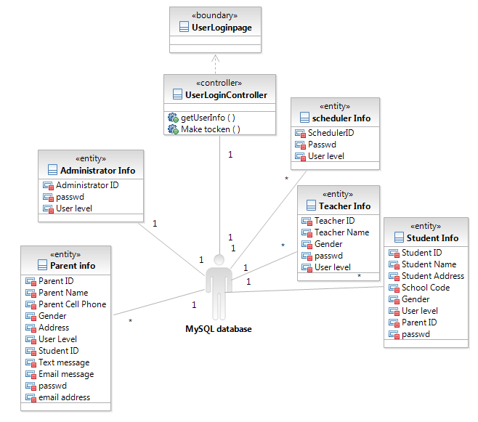
Figure 13: User Login Class Diagram
Table 51: User Login Class Description
Class | Type | Description
UserLoginPage | Boundary | Display the form to submit Log in
UserLoginController | Controller | Contains the logical computation for login and check user profile related account.  Controller will make a token for maintaining user’s status as login.
Administrator Info | Entity | There is an administrator who can manage user information. Only administrator would be able to input all user information.
Parent Info | Entity | All parent information is including student’s ID to represent relationships. To message notice service, phone# and email address information are included. To represent parent’s preference for message notice type, text message and email message attributions will have Boolean value.
Teacher Info | Entity | This represents basic information including name, id, password, and gender.  To distinguish between normal teacher and supervisor, there is level info.
Student Info | Entity | This represents basic information and parentID for relationships.
Scheduler Info | Entity | This represent basic information and User level to recognize different user type.  This user information would be maintained for LEMA scheduling system
MySQL database<<COTS>> | Component | MySQL Database will be used as a Database Management System.

Process Realization
For this design, each process has one realization. We used the same name for the process realization as the process to facilitate tracing. This remainder of this section shows the Sequence Diagrams for the high-risk processes. Each diagram shows that how the process can be implemented using our architecture and instances of the information classes.
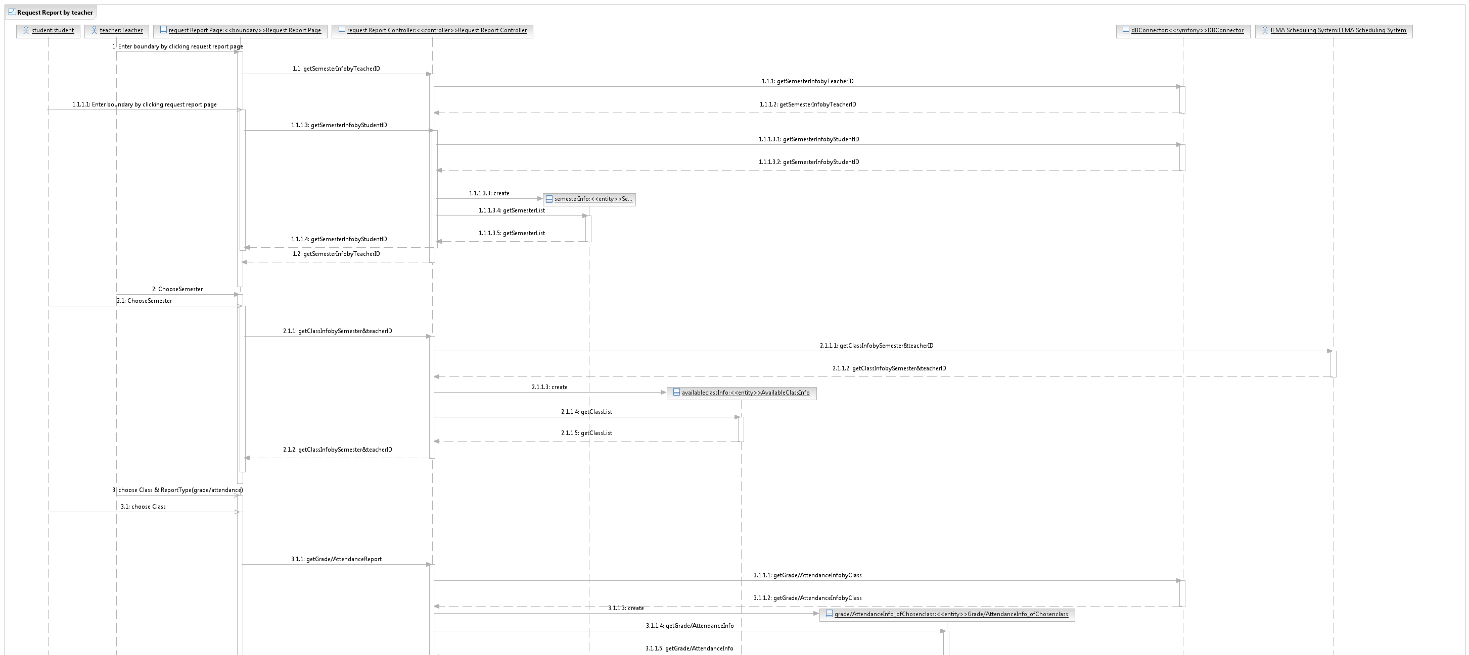
Figure 14: Request Report Sequence Diagram
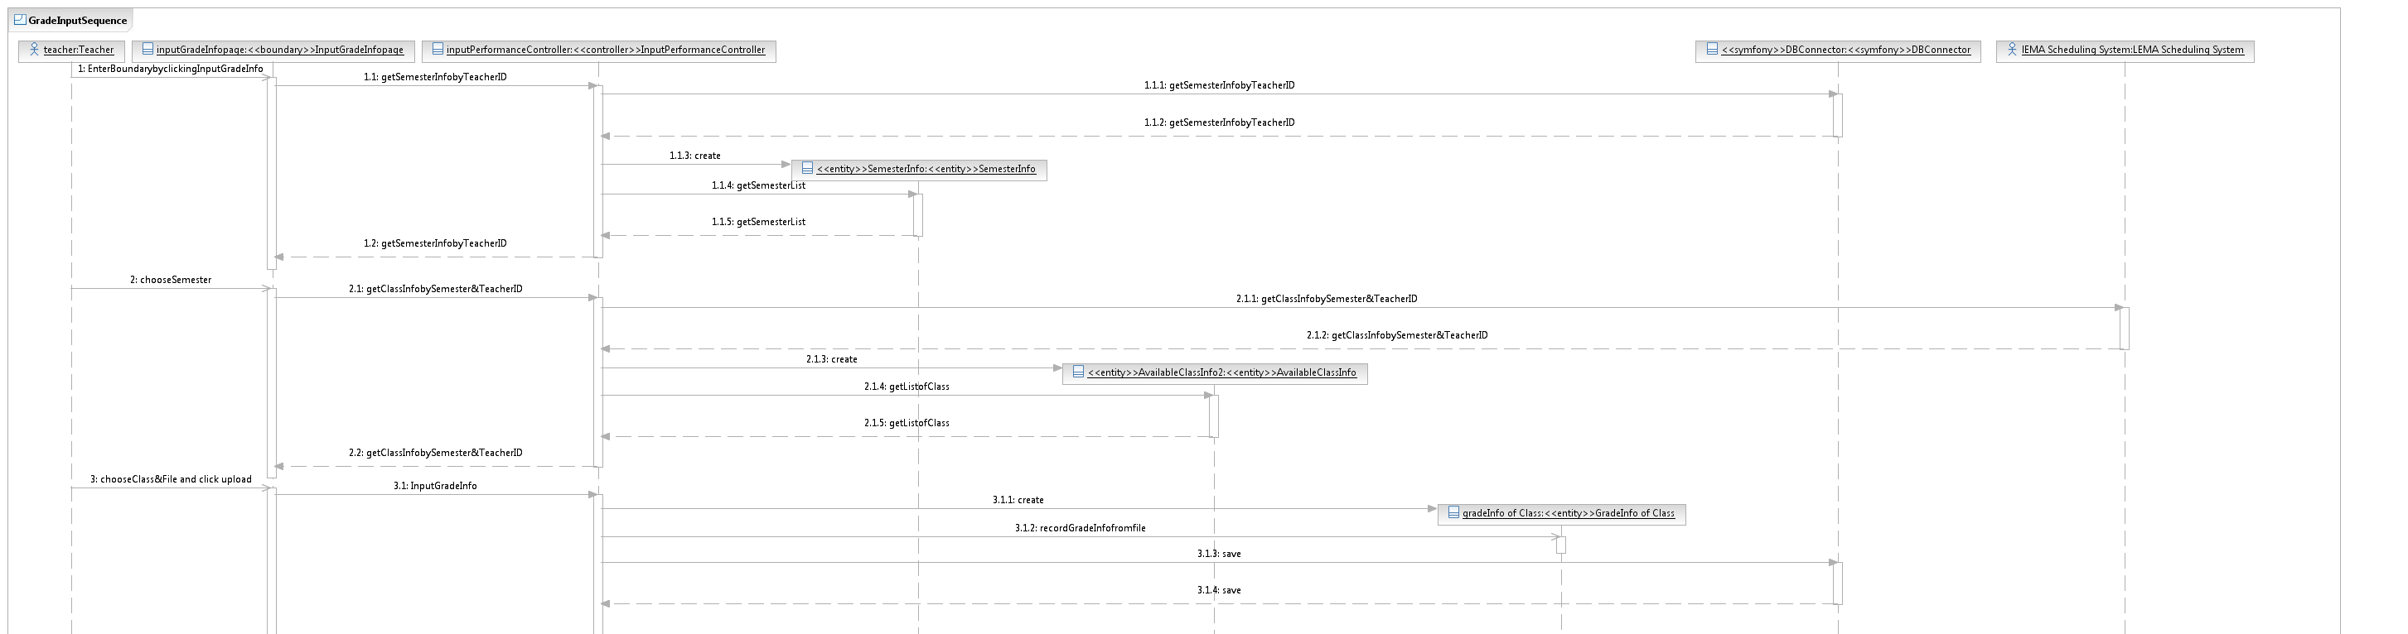
Figure 15: Grade Input Sequence Diagram

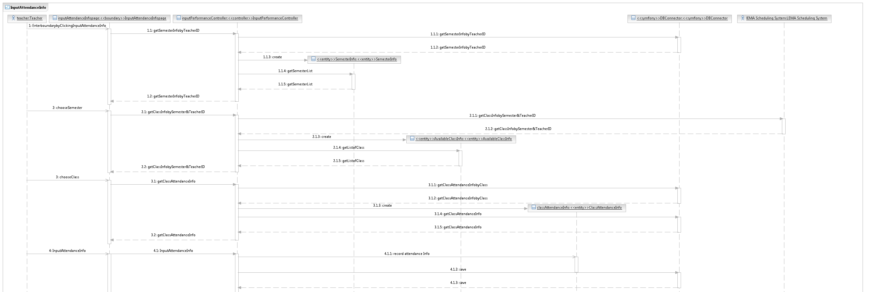
Figure 16:Input Attendance Info Sequence Diagram
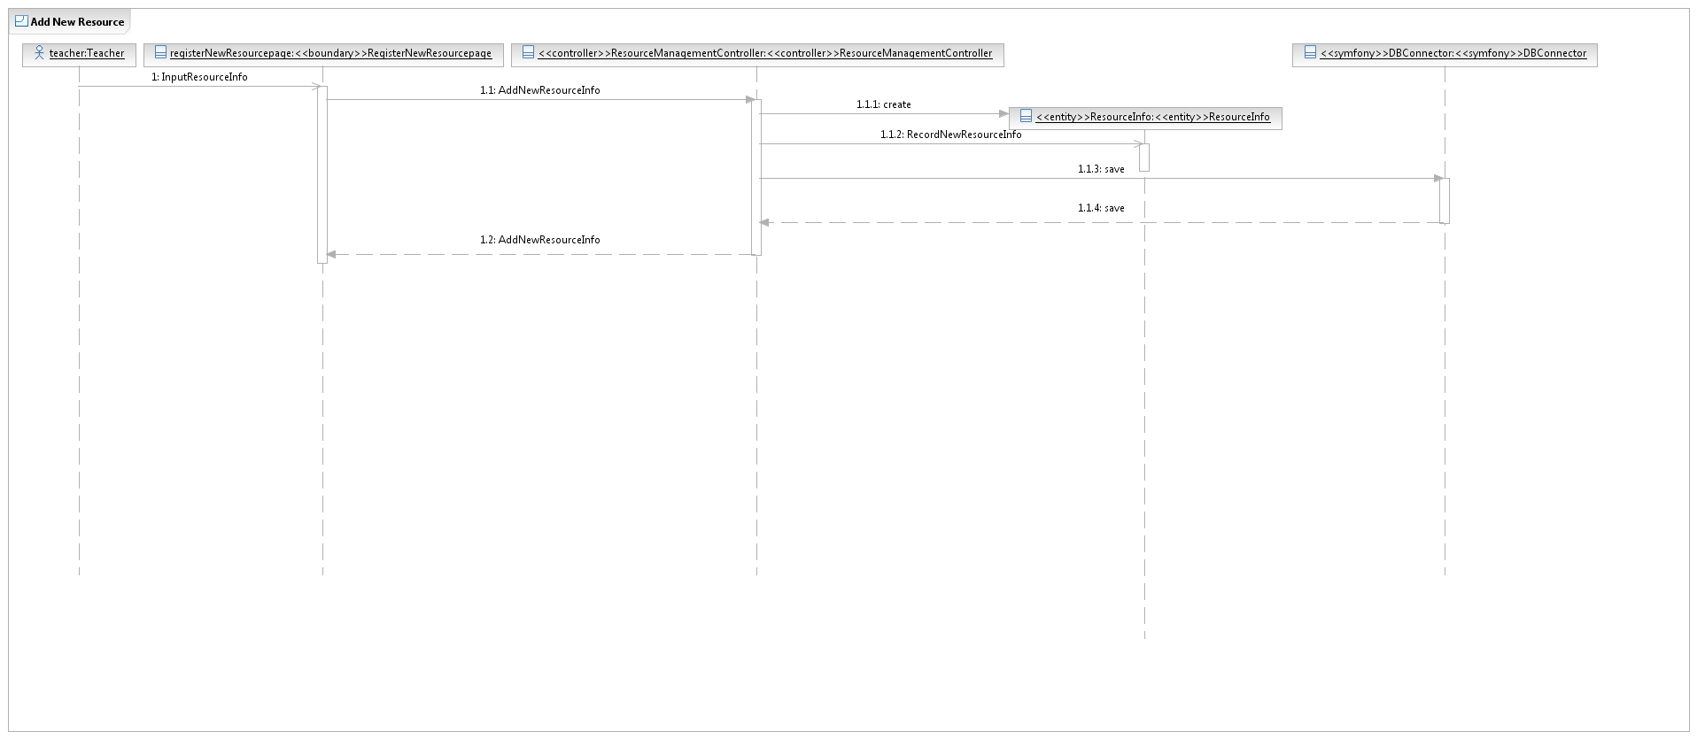
Figure 17: Add New Resource Sequence Diagram
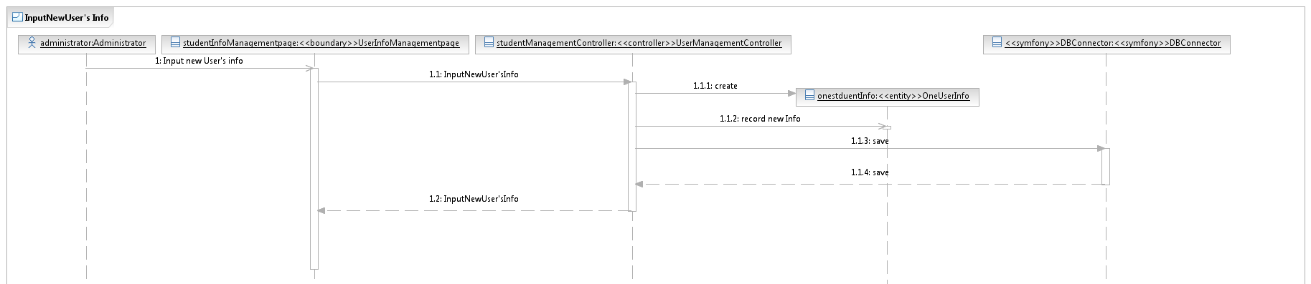
Figure 18: Input New User Info Sequence Diagram
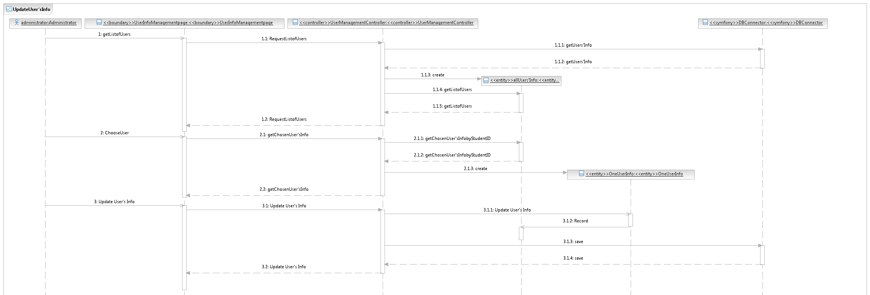
Figure 19: Update User Info Sequence Diagram
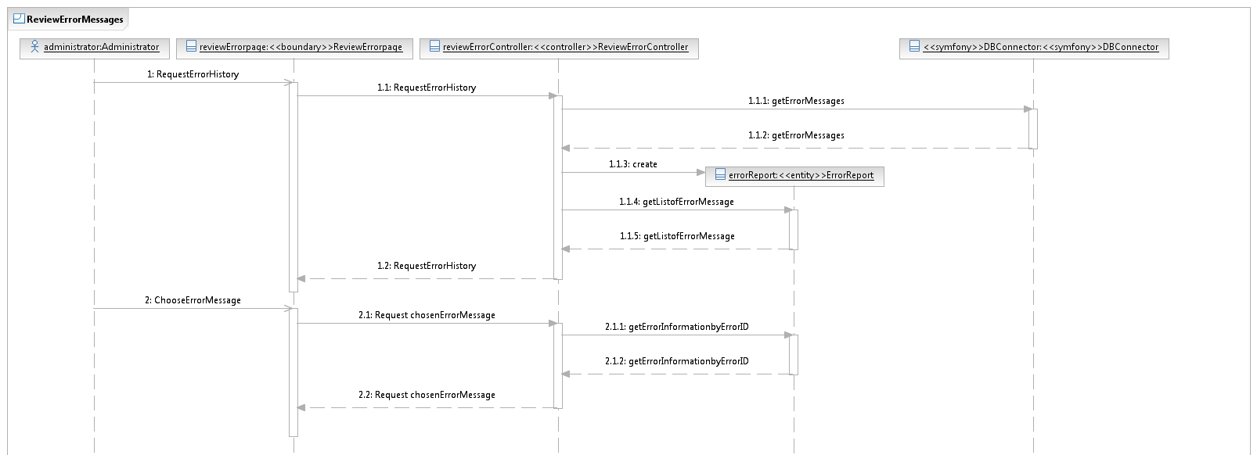
Figure 20: Review Error Message Sequence Diagram
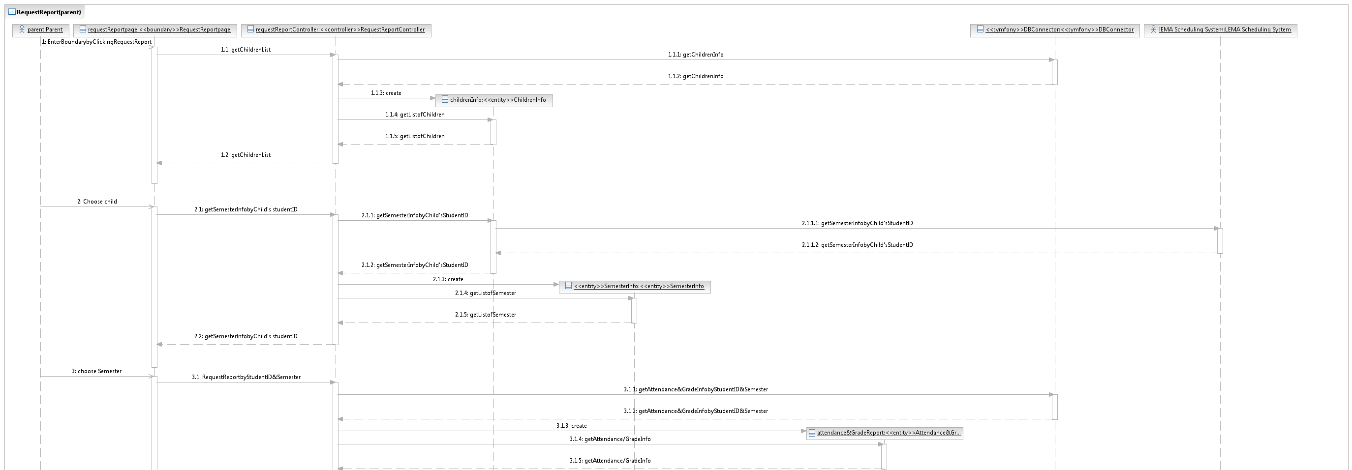
Figure 21: Request Report (parent)

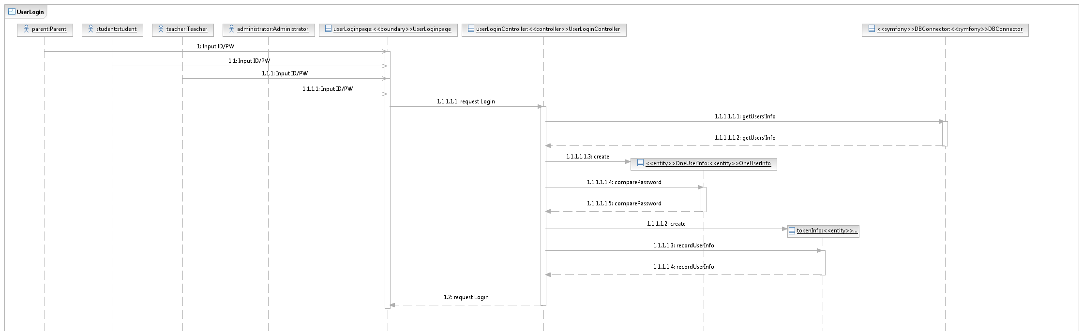
Figure 22: User Login Sequence Diagram
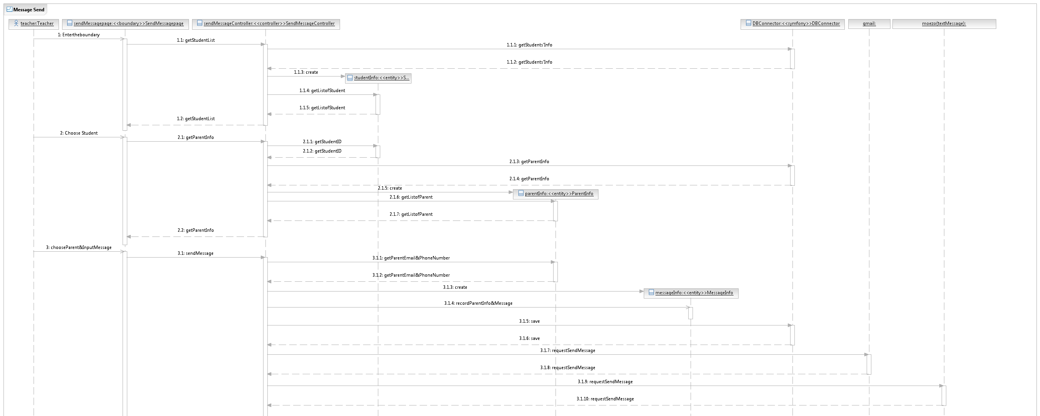
Figure 23: Message Send Sequence Diagram

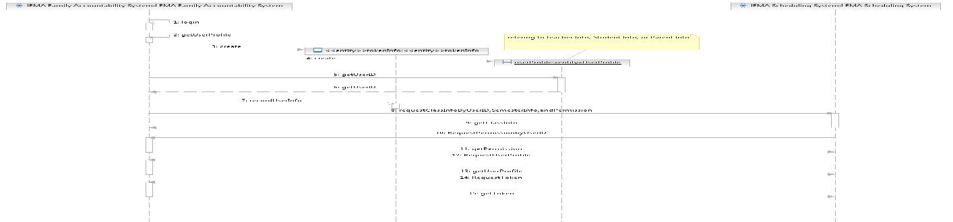
Figure 24: Rest Service Sequence Diagram

Design Rationale
We chose a 3-tiered architecture in order to design the LEMA Family Accountability System. The 3-tier architecture with application server separates the user interface part, business logic part, and DBMS part. Logic off-loaded from database system and GUI application, which improves performance.
The following list shows the 3-tiers architecture of the LEMA Family Accountability System and the specific components in each tier.

- User Interface Layer (PHP page)
1) User Interface Component – Web application page

- Business Logic Layer (PHP Component)
1) User Login component
2) Administrator Component
3) Message notification component
4) Resource Component
5) Student Performance Component
6) Report Component

- Database Management Layer
1) MySQL DBMS

Architectural Styles, Patterns and Frameworks
Table 52: Architectural Styles, Patterns, and Frameworks
Name | Description | Benefits, Costs, and Limitations
3-Tier Architecture | The 3-tier architecture separates the application into 3 different layers: user interface (GUI-Web Page), business logic (component), and domain and data access.  This architecture splits the user interface from the application logic using the middleware server.  The communication between the visual and data components is done via the business logic component, or the controllers. | Advantage  Development Issues:  • Complex application rules easy to  implement in application server  • Better Re-use:  If an standard object is employed, the  specific language of implementation of  the middle tier can be made transparent.  • Business logic off-loaded from database  server and client, which improves  performance.  • Changes to business logic automatically  enforced by server – changes require  only new application server software to  be installed.  • The middle tier can ensure that only  valid data is allowed to be updated in  the database.  • Application server logic is portable to  other database server platforms by virtue  of the application software  Performance:  • Superior performance for medium to  high volume environments  Disadvantage  Development Issues:  • More complex structure  • More difficult to setup and maintain.  Performance:  • The physical separation of application  servers containing business logic  functions and database servers  containing databases may moderately  affect performance.

